James Ray

CST-117

05/20/2018

<https://github.com/Rihoj/CST-117-Milestone-2>

Command Line response:

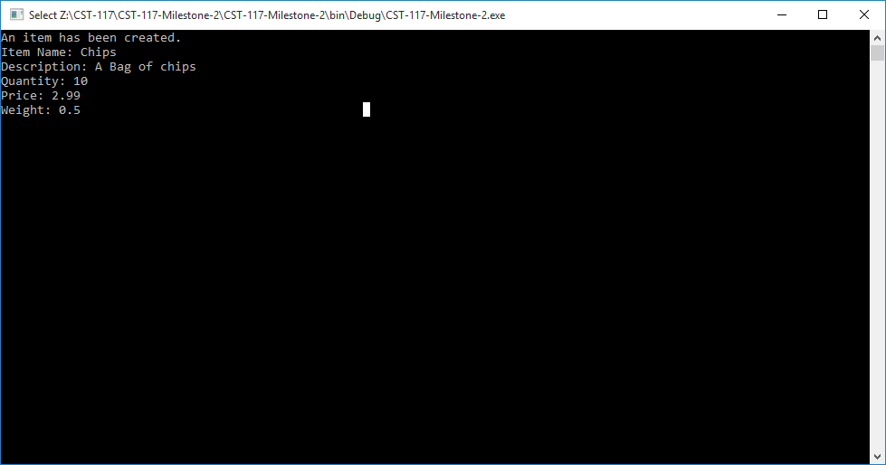

Tests Passed:

